Kristen Daniel, English Horn, and Oboe
Program Notes
A Game in the Redwoods – Mattea Williams
“In this piece, a heroic protagonist (the oboe) must battle a ravenous monster (the piano) in the redwood grove to save the day.” - Mattea Williams
Williams is a young composer who lives in the Bay area of California. She earned her BA degree in 2019 from the Baldwin Wallace Conservatory of Music where she studied composition, with piano being her primary instrument. Her Master’s was earned in the spring of 2021 where she continued to study composition at the University of Texas at Austin, Butler School of Music. In her music, Williams uses a combination of extended techniques, found objects (like a piece of paper being crumble, empty tin cans, chime stones, magnets, and a terracotta pot), and mixed media to blend colors and timbres that create vivid imagery and tell stories. It is important for Mattea to write and publish works at different grade levels so music students can have access to literature by a “living black woman composer.” She hopes her music will help encourage black youth to participate in classical music.

The Featherlight Ballet – Stephanie Berg
“Commissioned by the DDG Oboe Trio in 2013. This is easily one of my favorite pieces to date. My goal was to highlight the full expressive range of the oboe and English horn within this intricately woven setting, from the bright and sunny first movement, the mournfully sweet second movement, to the driving, dance-like third.” - Stephanie Berg

Stephanie Berg earned both her bachelors and masters degrees at the University of Missouri. She was commissioned to write a work for the MU University Philharmonic after she won the Sinquefield Composition Prize in 2009. Berg’s latest work is a solo E-flat clarinet work titled “Rituals of Antiquity,” completed in 2021.

Chrysalis – Alyssa Morris
“Chrysalis for English horn and piano was commissioned by Carolyn Hove, principal English horn of the L.A. Philharmonic, in 2014 for English horn and piano. It is a musical analogy of a caterpillar, its metamorphosis, and becoming a butterfly. Within the story is another message: to become spiritually changed.” - Alyssa Morris

Alyssa Morris is a very talented oboist and composer; she currently teaches oboe and music theory at Kansas State University. Morris, a highly sought-after clinician, and performer has traveled to perform in halls throughout the United States, Scandinavia, the British Isles, Western Europe, and Granada, Spain. She has been commissioned to write for oboists Dr. Mark Ostoich (University of Cincinnati College-Conservatory of Music) and Carolyn Hove (Principal English Horn of the Los Angeles Philharmonic, while also completing commissions for the River Oaks Chamber Orchestra, the Richmond Symphony Orchestra, and the U.S. Air Force Woodwind Quintet.

Play! – Kelly Vaneman
In this fun finale, Vaneman has written a work that brings the oboe and the audience together to create a one-of-a-kind performance. As each title indicates, you will Snap, Sing, and Stomp with the oboe during each movement as the oboe instructs. Be careful to watch for cutoffs as during this piece, the oboist will have to cut you off with the oboe itself. The most important thing to remember for this piece is to have fun!

Vaneman is currently the Professor of Oboe and musicology, and a music freshman mentor (for which she received the Above and Beyond Award in 2019) at the Carroll McDaniel Petrie School of Music at Converse College. She has appeared as a soloist with orchestras in Guatemala, Texas, Pennsylvania, and South Carolina. Vaneman and her flute-playing husband, Chris, are members of the duo Ensemble Radieuse, where they are dedicated to expanding the duo literature and engaging directly with the audience.

Dedication:
I have put my entire heart and soul into this recital, even some blood and tears (thanks reed making.) To be able to share such amazing music with my friends and my entire family means the world to me. The day of my recital hearing I had gotten the news that my grandfather, Don, had passed. My grandfather had such a love for music, I remember visiting my grandparents in Indiana and he would practice his bass clarinet for the Lafayette Citizens Band. Their performances were always right in front of a beautiful train station where there was a fountain, food carts, and tons of people gathered around for a great performance. I remember sitting in that ensemble once, grandpa had it arranged where my dad and I could both play in the ensemble and have three generations of Daniel’s in the same ensemble making music. My grandparents have always been a huge supporter of my music career, and it seems like right thing to do to dedicate this recital to such a wonderful, kind, music loving man. To everyone that has helped me get to this stage today I say from the bottom of my heart…
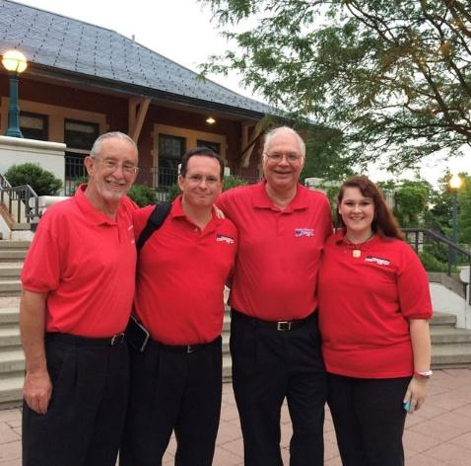
Thank you!

